**COS 221**

Practical Assignment 5

Group 5: <name>

|  |  |  |  |
| --- | --- | --- | --- |
| Jacobus Smit |  |  | u21489476 |
| Iwan de Jong |  |  | u22498037 |
| Rebecca Oosthuizen |  |  | u20512008 |
| Ashley Tullis |  |  | u22486985 |
| Dawie Reyneke |  |  | u21438112 |
| Tiaan Pouwels |  |  | u21675229 |

7 June 2023

**Task 1: Research**

As of May 2022, the tourism industry in South Africa accounts for 3,7% of the country’s gross domestic product. This industry is an important driver of South Africa’s economy and contributes to job creation and cultural exchange. In the fallout of the Covid-19 pandemic, the tourism industry was among the most negatively affected sectors, experiencing a global decline and resulting in a loss of countless jobs and businesses.

The National Department of Tourism wants to make South Africa a wine tourism hotspot, given its position as a global leader in wine production.

Wine is an alcoholic beverage made of fermented grape juice, while a winery is a licensed property that produces wine. There are a number of wine and winery varieties and characteristics that are pertinent to a wine tourist when deciding where to visit and what wines to try.

We, as a team of second year Computer Science students, have been contracted to design and implement a wine tourism application. Using our research on wine and wineries, these are the specifications of the project we will build:

**Functional Requirements:**

* The user should be able to login to the web-based application.
* The user should be able to view the various wines in the system, along with their year, type, producer, country of origin, alcohol percentage, price, rating, and the winery that holds them. The wines will be able to be easily searched and filtered through.
* The user should be able to view the various wineries in the system, along with their locations and verification statuses. The wineries will be able to be easily searched and filtered through.
* Users can be of type ‘general user’, ‘connoisseur’ or ‘manager’. General users will be able to leave general reviews of wines, while connoisseurs will be able to leave critic reviews of wines. Managers will each manage one winery.
* Verified wineries should be able to add new wines to their catalog.
* The application should be able to manage users, wines and wineries.
* The application should be able to update the database.
* The application should be able to suggest the best destinations based on a user’s location.

**Task 2: (E)ER-Diagram**

All diagram versions and how they improve on previous versions

Include all assumptions and necessary information

**Ver 1**

**Ver 2**

Added user and review types.

Changed wine age to production year.

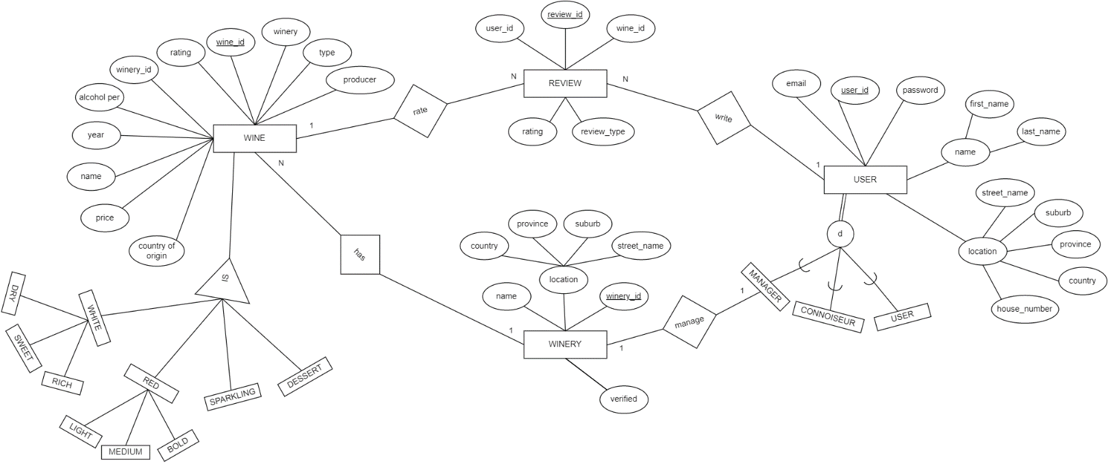



**Task 3: (E)ER-Diagram to Relational Mapping**

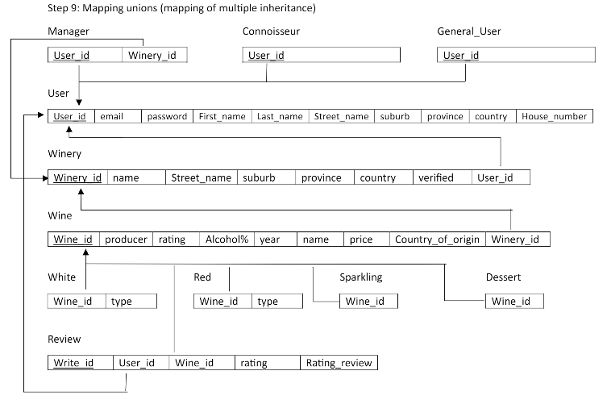

**Task 4: Relational Schema**

**Visual Diagram**

**SQL Statements**

CREATE DATABASE Practical5;

USE Practical5;

CREATE TABLE User (

User_id INT PRIMARY KEY,

Email VARCHAR(50),

Password VARCHAR(50),

First_name VARCHAR(50),

Last_name VARCHAR(50),

Street_name VARCHAR(50),

Suburb VARCHAR(50),

Province VARCHAR(50),

Country VARCHAR(50),

House_number VARCHAR(50)

);

CREATE TABLE Winery (

Winery_id INT PRIMARY KEY,

Name VARCHAR(50),

Street_name VARCHAR(50),

Suburb VARCHAR(50),

Province VARCHAR(50),

Country VARCHAR(50),

Verified INT,

User_id INT,

FOREIGN KEY (User_id) REFERENCES User(User_id)

);

CREATE TABLE Wine (

Wine_id INT PRIMARY KEY,

Type VARCHAR(50),

Producer VARCHAR(50),

Rating INT,

Alcohol% DECIMAL(5,2),

Age INT,

Name VARCHAR(50),

Price INT,

Country_of_Origin VARCHAR(50),

Winery_id INT,

FOREIGN KEY (Winery_id) REFERENCES Winery(Winery_id)

);

CREATE TABLE Review (

Write_id INT PRIMARY KEY,

User_id INT,

Wine_id INT,

FOREIGN KEY (User_id) REFERENCES User(User_id),

FOREIGN KEY (Wine_id) REFERENCES Wine(Wine_id)

);

CREATE TABLE White (

Wine_id INT,

Type VARCHAR(50),

FOREIGN KEY (Wine_id) REFERENCES Wine(Wine_id)

);

CREATE TABLE Red (

Wine_id INT,

Type VARCHAR(50),

FOREIGN KEY (Wine_id) REFERENCES Wine(Wine_id)

);

CREATE TABLE Sparkling (

Wine_id INT,

FOREIGN KEY (Wine_id) REFERENCES Wine(Wine_id)

);

CREATE TABLE Dessert (

Wine_id INT,

FOREIGN KEY (Wine_id) REFERENCES Wine(Wine_id)

);

**Task 6: Data**

Explain population method choice and give reasons @Dawie

**Task 8: Contributions**

Jacobus Smit

Iwan de Jong

Rebecca Oosthuizen

* Managed PDF
* Implemented filtering and searching of tables

Ashley Tullis

Dawie Reyneke

Tiaan Pouwels